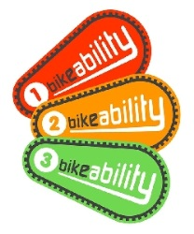 | TWO MOORS PRIMARY SCHOOL  Cowleymoor Road, Tiverton EX16 6HH  Tel. No. 01884 253006  www.twomoors.devon.sch.uk | 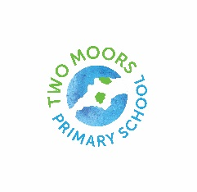
YEAR 4 BIKEABILITY
Wednesday 8th & Thursday 9th February 2023

Dear Parents,

We are happy to be able to offer a Learn to ride course and Level 1 Bikeability course for the Year 4 children from Wednesday 8th February.

Learn to ride: Will take place on the school playground. This will take place on Wednesday 8th and Thursday 9th February and your child will need to bring a bike and helmet please. If you don’t have access to these, can you please let the class teacher know.

Level 1:
This will also take place on the school playground on Wednesday 8th and Thursday 9th February. The children will be in small groups with one group going out in the morning and one in the afternoon. Your child will need to bring a bike and helmet please. If you don’t have access to these, can you let the class teacher know.

If your child can ride already, then please complete the level 1 consent form.
If your child is less confident or cannot yet ride, please complete the learn to ride consent form.

If you would like your child to take part in the course please can you return the attached consent form to the class teachers by Wednesday 1st February please.

Yours sincerely,

Mrs. C. Buckley
Headteacher

