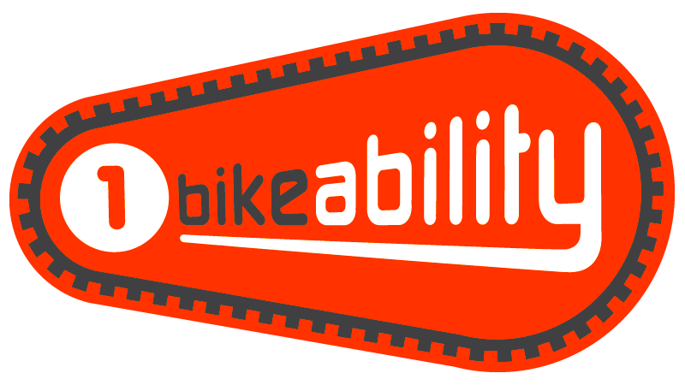
Take YOUR CYCLING seriously, don’t miss out on Bikeability!

With Bikeability Level 1, you’ll learn to control and master your cycle in a safe space away from traffic such as a playground or closed car park. Level 1 is for children in Year 3 or 4 who are able to ride a cycle without stabilisers. You will usually be trained in a group of up to 12 per instructor.

At Level 1 you can:
- Prepare yourself and your cycle for cycling
- Get on and off your cycle without help
- Start off, pedal and stop with control
- Pedal along, use gears and avoid objects
- Look all around and behind, and control the cycle
- Share space with pedestrians and other cyclists

Parents & Carers
Please read this information carefully and return the consent form to your child’s school. The school will inform you about dates when the course for your child is due.

The Bikeability Trust have lots of information that we recommend you look at and go through with your child before their course; www.bikeability.org.uk/about-cycle-training/cycle-training-for-children/

Note each child must be able to ride a cycle (without stabilisers, have good control and balance) before enrolling for this course. There may be courses to support those who can’t ride.

All trainees must provide a cycle in a suitable condition (a cycle check diagram is provided) and a helmet must be worn. In certain areas, spare cycles may be available. High visibility waistcoats will be provided. All courses are conducted by approved National Standard Instructors, who are DBS checked and have attended a first aid course. Please ensure your child is wearing appropriate clothing suitable for cycling and the weather conditions of the day.

We request that you discuss the Bikeability course with your child, and encourage them to practice what they have learnt each session - maybe by accompanying them on a cycle ride and discussing the Highway Code. Your child must attend every session - if they miss any sessions, they may not be able to complete the course.
For more information about Bikeability, please visit https://bikeability.org.uk
Helmet and Cycle Checklist
Use the diagram below to check your child’s helmet fits and that their cycle is in a safe, roadworthy condition.
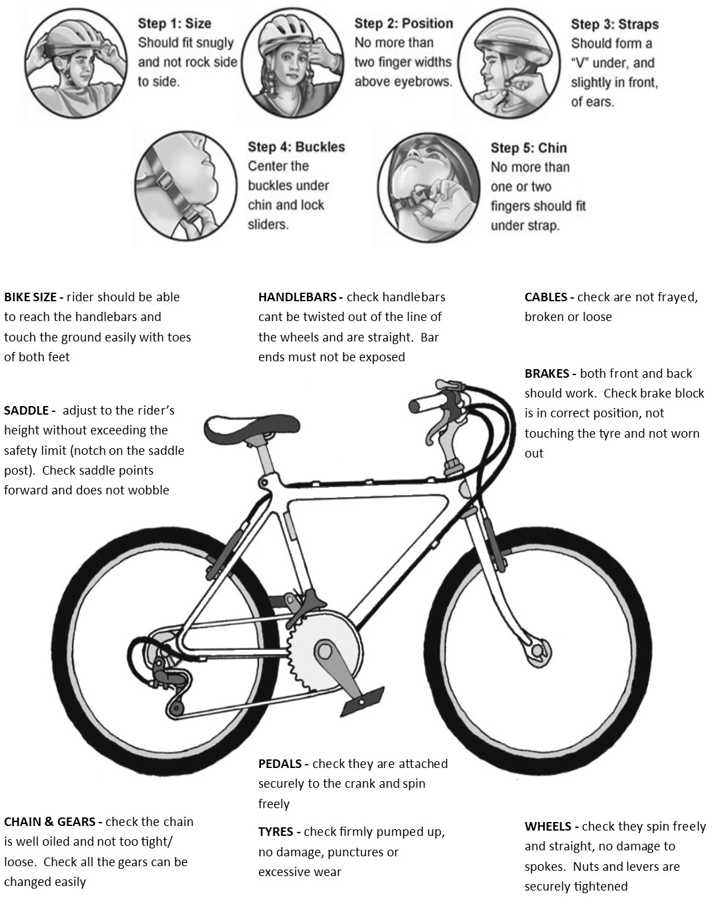

Bikeability Level 1 Consent Form (PLEASE USE BLOCK CAPITALS IF WRITING BY HAND)
Child’s Name
Child’s School
Date of Birth
School Year
(all participants must be in Year 3 or Year 4)
Parent/Carer Name
Telephone Number
Email Address
Emergency Contact Name & Number
(if different from above)
Please provide details of any medical conditions that we need to know about…
Ensure that if your child requires medication e.g. inhalers, that they have it with them at all times during the course
Please provide details of any learning support your child needs at school…
Does your child have any learning or behaviour issues that we should be aware of so that your child has a more positive experience?
Does your child have 1:1 support at school?
My child can ride a cycle competently, without stabilisers |  | Yes / No
My child regularly cycles to school |  | Yes / No
RIDER CHARACTERISTICS
Delivery of this cycle training is subsidised by The Bikeability Trust. To support equal delivery and monitoring of cycle training across England, the Bikeability Trust is required to collect information about rider characteristics. The data will enable the Trust to demonstrate the need for additional funding and target interventions to ensure every child can receive Bikeability cycle training. Your answers will be fully anonymised.
Child’s gender  This information is recorded for monitoring only by the Bikeability Trust. No personal details are recorded. |  | Female / Male / Other / Prefer not to say
Tick the option below that best describes your child’s ethnicity
This information is recorded for monitoring only by the Bikeability Trust. No personal details are recorded.
Asian – Bangladeshi |  | Asian – Chinese
Asian – Indian |  | Asian – Pakistani
Asian – Any other Asian background |  | Black – African
Black – Caribbean |  | Black – Any other Black background
Mixed – White & Asian |  | Mixed – White & Black African
Mixed – White & Black Caribbean |  | Mixed – Any other Mixed background
White – Gypsy/Roma |  | White – Irish
White – Traveller of Irish Heritage |  | White – British
White – Any other White background |  | Any other ethnic group
Any other ethnic group – Arab |  | Prefer not to say
Does your child have special educational needs or disability (SEND)?  This information is recorded for monitoring only by the Bikeability Trust. No personal details are recorded. |  | Yes / No / Prefer not to say
CONTINUED OVERLEAF…
Is your child eligible for free school meals?  Note that this does not include the Universal Free School Meals programme. If you are unsure, please check with your child's school or select 'Prefer not to say’. | Yes / No / Prefer not to say

I have read all of the information and understand that completion of this form acts as my consent for my child to take part in a cycle training course and by signing below I agree the following:

- I give permission for my child to be supported for balance as necessary. If my child cannot ride a cycle, I consent to them taking part in playground based “Learn to Ride” training where possible
- Whilst every care will be taken to ensure your child's safety, your instructor provides public liability insurance only and not personal accident insurance for anyone taking part in this course, nor do they accept responsibility for the actions or personal behaviour of participants. Devon County Council, the Plymouth School Sports Partnership, your training provider and instructor are not responsible for any injury to persons, or loss or damage to property, which is not the result of the negligence of an instructor.
- I will ensure my child’s helmet fits and their cycle is in a safe, usable condition (please refer to cycle checklist)
- I consent to allowing the instructor to make necessary adjustments to my child’s cycle to ensure that my child can take part in the course
- I consent to my child receiving any first aid treatment as required
- I understand that any participants who persistently misbehave or put others in danger will be asked to leave the cycle sessions and will not be allowed to attend in future

Child’s Name:

Parent/Carer Signature: Date:

