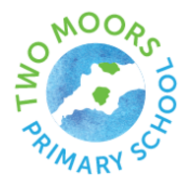
Vision and Ethos Statement

At Two Moors Primary School:

- We value the individuality of all of our children and set high expectations for them, regardless of their abilities or background

- We inspire our children to believe in themselves and in their true potential

- We support each child on their own unique learning journey

- We strive to overcome any barrier that stands in their way

- We teach our children to work together and to never give up

- We celebrate their success – in both their academic achievements and in their development into young people who can be role models for our whole community.

“We are all unique: We inspire, believe and achieve together”
The School Council February 2022

Reviewed 5th April 2022
Next review May 2023

